JRM + ESP32

- Complete System Flow

POWER ON
↓
Language Selection
↓
Route Selection
↓
GPS Fast Lock
↓
Coordinate Matching
↓
Zone Detection
↓
LED Control
↓
Voice Announcement
↓
Overspeed Alert
↓
Continuous Monitoring

GPS Based Intelligent Audio Alert System
C
- What Happens at Each Stage
- When 5V power is supplied
- ESP32 boots
- GPS module starts
- DFPlayer initializes
- LEDs initialize
- Route database loads from memory
- Language Selection
1 = Marathi , 2 = Hindi , 3 = English . Based on selected language:
Language Folder Selected.

- Route selection

Route 510 , Route 511 ,Route 512 .from Loaded information contains: Coordinates ,Zone IDs , Speed limits.
- GPS Lock
Latitude Available ,Longitude Available ,Satellite Lock Available .
- Coordinate Matching
Current co-ordinates matches with load route files co-ordinate .

Zone Detection and LED Control
Based on detected zone LED indication changes to Red ,Yellow, Green .
- Voice Announcement
As per zone zone changing voice command and overspeed command .

Overspeed Alert
Every zone may have a predefined speed limit as vehical speed exceed that limit overspeed buzzer start beeping till speed becoms normal again .

- Components Used
Hardware :
- ESP32 Development Board
- GPS Module (L80)
- DFPlayer Mini MP3 Module
- MicroSD Card (8 GB)
- Speaker (4Ω 3W)
- 5 V DC Power Supply
- LED’s (Red,Yellow,Green)
- Current Limiting Resistors
- Buzzer (5V)
- Connecting Wires and Connectors

Software :
- Arduino IDE
- ESP32 Board Package
- TinyGPS++ Library
- DFRo
- LittleFS Library
- UART Communication Libraries

Main Features Implemented
✅GPS Fast Lock
✅ Coordinate Matching
✅ Zone Detection
✅ LED Indication
✅ Voice Announcements
✅ Overspeed Detection
✅ Speed Limit Monitoring
✅ Continuous GPS Tracking
✅ Multi-route Support
✅ Multi-language Support

- Connections

GPS Module → ESP32
GPS VCC → ESP32 5V
GPS GND → ESP32 GND
GPS TX → ESP32 GPIO 16(RX1)
GPS RX → ESP32 GPIO 17(TX1)

SD Card Module → ESP32
VCC → 3.3V
GND → GND
MISO → GPIO19
MOSI → GPIO23
SCK → GPIO18
CS → GPIO5

MAX98357 → ESP32
VIN → 5V
GND → GND
BCLK → GPIO 32
LRC → GPIO 33
DIN→ GPIO 22

Speaker → MAX98357
Speaker + → +ve
Speaker - → -ve

Buzzer → ESP32
VCC → 5 V
GND → GPIO 14

LED’s → ESP32
Red (+ve) → GPIO 25
Yellow (+ve) → GPIO 26
Green (+ve) → GPIO 27
LED’s (-ve) → ESP32 GND

MicroSD Card
Insert MicroSD Card into DFPlayer Mini & Store voice files inside card such as:
//English //Hindi //Marathi Zone Sound
0001.mp3 0101.mp3 0201.mp3 For Green
0002.mp3 0102.mp3 0202.mp3 For Yellow
0003.mp3 0103.mp3 0203.mp3 For Red
0004.mp3 0104.mp3 0204.mp3 Over speed

Power Connections

ESP32
5V Supply → ESP32 VIN
GND → ESP32 GND

GPS
ESP32 3.3V → GPS VCC
ESP32 GND → GPS GND

DFPlayer

5V Supply → DFPlayer VCC
GND → DFPlayer GND
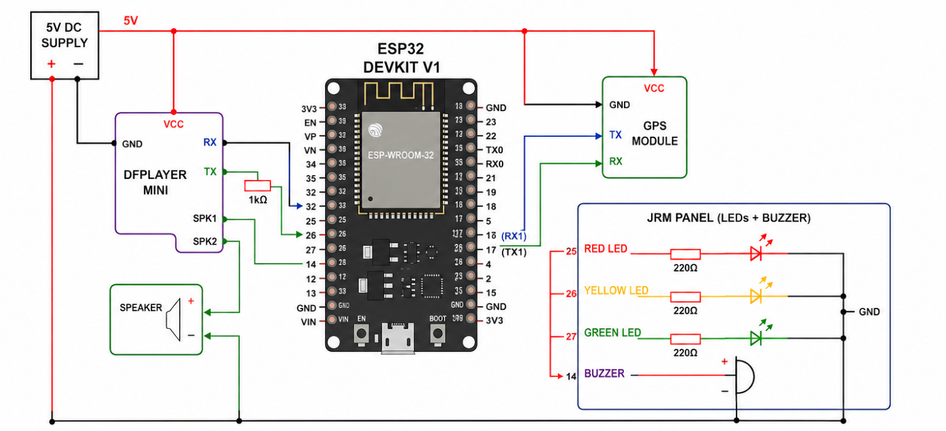

- JRM Panel

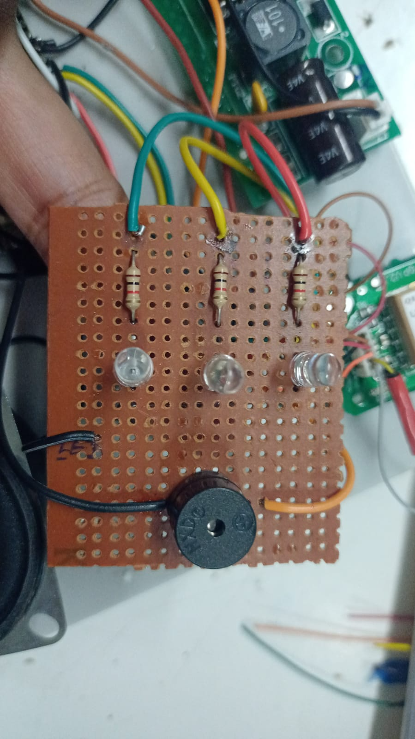
-ve

BUZZER
R1,R2,R3(220Ω)
+ve
YELLOW
GREEN
RED

/*
* ============================================================
* GPS BASED INTELLIGENT AUDIO ALERT SYSTEM
* For School / College Bus Safety
* ============================================================
* Hardware : ESP32 DevKit V1
* GPS : L80 GPS Module
* Audio : MAX98357 I2S Amplifier
* Storage : Micro SD Card Module
* BT : Bluetooth Classic Serial
* Author : Production Build v1.0
* Date : 2026
* ============================================================
*
* PIN CONFIGURATION:
* GPS RX -> GPIO17
* GPS TX -> GPIO16
* Push Button -> GPIO13
* Green LED -> GPIO27
* Yellow LED -> GPIO26
* Red LED -> GPIO25
* Buzzer -> GPIO14
* MAX98357 DIN -> GPIO22
* MAX98357 BCLK -> GPIO32
* MAX98357 LRC -> GPIO33
* SD CS -> GPIO5
* SD MOSI -> GPIO23
* SD MISO -> GPIO19
* SD SCK -> GPIO18
* ============================================================
*/

// ─────────────────────────────────────────────
// INCLUDES
// ─────────────────────────────────────────────
#include <Arduino.h>
#include <TinyGPSPlus.h>
#include <HardwareSerial.h>
#include <BluetoothSerial.h>
#include <SD.h>
#include <SPI.h>
#include <Audio.h> // ESP32-audioI2S by Schreibfaul1
#include <math.h>

// ─────────────────────────────────────────────
// PIN DEFINITIONS
// ─────────────────────────────────────────────
#define PIN_GPS_RX 17
#define PIN_GPS_TX 16
#define PIN_BUTTON 13
#define PIN_LED_GREEN 27
#define PIN_LED_YELLOW 26
#define PIN_LED_RED 25
#define PIN_BUZZER 14
#define PIN_I2S_DIN 22
#define PIN_I2S_BCLK 32
#define PIN_I2S_LRC 33
#define PIN_SD_CS 5
#define PIN_SD_MOSI 23
#define PIN_SD_MISO 19
#define PIN_SD_SCK 18

// ─────────────────────────────────────────────
// PROJECT CONSTANTS
// ─────────────────────────────────────────────
#define BLUETOOTH_NAME "JRM+ESP32"
#define MATCH_RADIUS_M 100.0 // metres
#define OVERSPEED_COOLDOWN_MS 10000UL // 10 seconds
#define BUTTON_DEBOUNCE_MS 50UL
#define BUTTON_TIMEOUT_MS 3000UL // wait 3 s after last press
#define GPS_BAUD 9600
#define BUZZER_BEEP_ON_MS 150UL
#define BUZZER_BEEP_OFF_MS 150UL
#define BUZZER_BEEP_COUNT 3
#define EARTH_RADIUS_M 6371000.0

// Speed limits per zone (km/h)
#define SPEED_LIMIT_GREEN 65.0
#define SPEED_LIMIT_YELLOW 40.0
#define SPEED_LIMIT_RED 30.0

// ─────────────────────────────────────────────
// ENUMERATIONS
// ─────────────────────────────────────────────
enum Language {
LANG_NONE = 0,
LANG_ENGLISH = 1,
LANG_HINDI = 2,
LANG_MARATHI = 3
};

enum Zone {
ZONE_NONE = 0,
ZONE_GREEN = 'G',
ZONE_YELLOW = 'Y',
ZONE_RED = 'R'
};

enum SystemState {
STATE_LANGUAGE_SELECT,
STATE_BT_ROUTE_SELECT,
STATE_LOAD_ROUTE,
STATE_GPS_LOCK,
STATE_MONITORING
};

// ─────────────────────────────────────────────
// DATA STRUCTURES
// ─────────────────────────────────────────────
struct RoutePoint {
double latitude;
double longitude;
char zone; // 'G', 'Y', 'R'
};

// ─────────────────────────────────────────────
// GLOBALS – Hardware Instances
// ─────────────────────────────────────────────
TinyGPSPlus gps;
HardwareSerial gpsSerial(2); // UART2 for GPS
BluetoothSerial btSerial;
Audio audio;

// ─────────────────────────────────────────────
// GLOBALS – System State
// ─────────────────────────────────────────────
SystemState systemState = STATE_LANGUAGE_SELECT;
Language selectedLanguage = LANG_NONE;
String selectedRoute = "";
String routeFilePath = "";

// Route points loaded from SD card
static const uint16_t MAX_ROUTE_POINTS = 500;
RoutePoint routePoints[MAX_ROUTE_POINTS];
uint16_t routePointCount = 0;

// GPS data
double currentLat = 0.0;
double currentLon = 0.0;
double currentSpeed = 0.0; // km/h

// Zone tracking
char currentZone = ZONE_NONE;
char lastAnnouncedZone = ZONE_NONE;

// Overspeed tracking
bool overspeedActive = false;
unsigned long overspeedCooldownStart = 0;

// Button tracking
int buttonPressCount = 0;
unsigned long lastButtonPress = 0;
bool buttonWasHigh = true; // INPUT_PULLUP – idle HIGH
unsigned long lastDebounce = 0;
bool languageConfirmed = false;

// Buzzer non-blocking state
bool buzzerActive = false;
int buzzerBeepsLeft = 0;
bool buzzerToneOn = false;
unsigned long buzzerLastChange = 0;

// Audio state
bool audioPlaying = false;
String lastAudioFile = "";

// Bluetooth input buffer
String btBuffer = "";

// Millis timestamps
unsigned long lastGPSRead = 0;
unsigned long lastZoneCheck = 0;

// ─────────────────────────────────────────────
// FORWARD DECLARATIONS
// ─────────────────────────────────────────────
void selectLanguage();
void readBluetoothRoute();
bool loadRouteFile(const String& path);
void readGPS();
double calculateDistance(double lat1, double lon1, double lat2, double lon2);
char detectZone();
void updateLEDs(char zone);
void playAudio(const String& filename);
void checkOverspeed(char zone, double speed);
void beepBuzzer();
void serviceBuzzer();
String getZoneAudioFile(char zone);
String getOverspeedAudioFile();
double getSpeedLimit(char zone);
void printDebugInfo();
void blinkLED(int pin, int times, int onMs, int offMs);

// ─────────────────────────────────────────────
// SETUP
// ─────────────────────────────────────────────
void setup() {
Serial.begin(115200);
Serial.println(F("========================================"));
Serial.println(F(" GPS Bus Safety System – Starting Up "));
Serial.println(F("========================================"));

// GPIO init
pinMode(PIN_BUTTON, INPUT_PULLUP);
pinMode(PIN_LED_GREEN, OUTPUT);
pinMode(PIN_LED_YELLOW, OUTPUT);
pinMode(PIN_LED_RED, OUTPUT);
pinMode(PIN_BUZZER, OUTPUT);
digitalWrite(PIN_LED_GREEN, LOW);
digitalWrite(PIN_LED_YELLOW, LOW);
digitalWrite(PIN_LED_RED, LOW);
digitalWrite(PIN_BUZZER, LOW);

// GPS Serial
gpsSerial.begin(GPS_BAUD, SERIAL_8N1, PIN_GPS_RX, PIN_GPS_TX);
Serial.println(F("[GPS] Serial started on UART2"));

// Bluetooth
btSerial.begin(BLUETOOTH_NAME);
Serial.print(F("[BT] Started as: "));
Serial.println(BLUETOOTH_NAME);

// SD Card
SPI.begin(PIN_SD_SCK, PIN_SD_MISO, PIN_SD_MOSI, PIN_SD_CS);
if (!SD.begin(PIN_SD_CS)) {
Serial.println(F("[SD] FAILED – check wiring/card!"));
for (int i = 0; i < 5; i++) {
digitalWrite(PIN_LED_RED, HIGH); delay(200);
digitalWrite(PIN_LED_RED, LOW); delay(200);
}
} else {
Serial.println(F("[SD] Card mounted OK"));
}

// I2S Audio
audio.setPinout(PIN_I2S_BCLK, PIN_I2S_LRC, PIN_I2S_DIN);
audio.setVolume(18); // 0–21
Serial.println(F("[AUDIO] I2S configured"));

// Startup visual confirmation – all LEDs ON briefly
digitalWrite(PIN_LED_GREEN, HIGH);
digitalWrite(PIN_LED_YELLOW, HIGH);
digitalWrite(PIN_LED_RED, HIGH);
delay(600);
digitalWrite(PIN_LED_GREEN, LOW);
digitalWrite(PIN_LED_YELLOW, LOW);
digitalWrite(PIN_LED_RED, LOW);

Serial.println(F("[SYS] Press button: 1=English | 2=Hindi | 3=Marathi"));
Serial.println(F("[SYS] Waiting for language selection..."));
}

// ─────────────────────────────────────────────
// MAIN LOOP
// ─────────────────────────────────────────────
void loop() {
// Always service audio loop (required by ESP32-audioI2S)
audio.loop();

// Always service non-blocking buzzer
serviceBuzzer();

// State machine
switch (systemState) {

// ── 1. LANGUAGE SELECTION ──────────────────
case STATE_LANGUAGE_SELECT:
selectLanguage();
break;

// ── 2. BLUETOOTH ROUTE SELECTION ──────────
case STATE_BT_ROUTE_SELECT:
readBluetoothRoute();
break;

// ── 3. LOAD ROUTE FILE ─────────────────────
case STATE_LOAD_ROUTE:
if (loadRouteFile(routeFilePath)) {
Serial.printf("[ROUTE] Loaded %d points from %s\n",
routePointCount, routeFilePath.c_str());
systemState = STATE_GPS_LOCK;
Serial.println(F("[GPS] Waiting for GPS lock..."));
} else {
Serial.println(F("[ERROR] Route load failed – check SD card!"));
blinkLED(PIN_LED_YELLOW, 4, 200, 200);
systemState = STATE_BT_ROUTE_SELECT;
}
break;

// ── 4. WAIT FOR GPS FIX ───────────────────
case STATE_GPS_LOCK:
readGPS();
if (gps.location.isValid() && gps.location.age() < 2000) {
currentLat = gps.location.lat();
currentLon = gps.location.lng();
currentSpeed = gps.speed.kmph();
Serial.printf("[GPS] Lock acquired: %.6f, %.6f Speed: %.1f km/h\n",
currentLat, currentLon, currentSpeed);
blinkLED(PIN_LED_GREEN, 3, 150, 150);
systemState = STATE_MONITORING;
Serial.println(F("[SYS] === MONITORING STARTED ==="));
}
break;

// ── 5. CONTINUOUS MONITORING ──────────────
case STATE_MONITORING:
readGPS();

if (millis() - lastZoneCheck >= 500) { // check every 500ms
lastZoneCheck = millis();

char newZone = detectZone();

if (newZone != ZONE_NONE && newZone != currentZone) {
currentZone = newZone;
updateLEDs(currentZone);

// Play zone audio only when zone changes
if (currentZone != lastAnnouncedZone) {
lastAnnouncedZone = currentZone;
String audioFile = getZoneAudioFile(currentZone);
playAudio(audioFile);
}
}

checkOverspeed(currentZone, currentSpeed);
printDebugInfo();
}
break;
}
}

// ─────────────────────────────────────────────
// FUNCTION: selectLanguage()
// - Reads button presses with debounce
// - 3-second timeout after last press
// - 1=English, 2=Hindi, 3=Marathi
// ─────────────────────────────────────────────
void selectLanguage() {
bool buttonNow = (digitalRead(PIN_BUTTON) == LOW); // LOW = pressed (pull-up)

// Debounce
if (buttonNow != !buttonWasHigh) {
lastDebounce = millis();
}

if ((millis() - lastDebounce) > BUTTON_DEBOUNCE_MS) {
if (buttonNow && buttonWasHigh) {
// Falling edge – button pressed
buttonWasHigh = false;
lastButtonPress = millis();
buttonPressCount++;

// Visual feedback per press
digitalWrite(PIN_LED_GREEN, HIGH);
delay(80);
digitalWrite(PIN_LED_GREEN, LOW);

Serial.printf("[BTN] Press #%d detected\n", buttonPressCount);
} else if (!buttonNow && !buttonWasHigh) {
buttonWasHigh = true; // button released
}
}

// After 3-second timeout, confirm selection
if (buttonPressCount > 0 &&
(millis() - lastButtonPress) >= BUTTON_TIMEOUT_MS) {

switch (buttonPressCount) {
case 1:
selectedLanguage = LANG_ENGLISH;
Serial.println(F("[LANG] Selected: ENGLISH"));
break;
case 2:
selectedLanguage = LANG_HINDI;
Serial.println(F("[LANG] Selected: HINDI"));
break;
case 3:
selectedLanguage = LANG_MARATHI;
Serial.println(F("[LANG] Selected: MARATHI"));
break;
default:
Serial.printf("[LANG] Invalid count %d – defaulting to English\n",
buttonPressCount);
selectedLanguage = LANG_ENGLISH;
break;
}

// Confirm with LED flash
int pin = (selectedLanguage == LANG_ENGLISH) ? PIN_LED_GREEN :
(selectedLanguage == LANG_HINDI) ? PIN_LED_YELLOW :
PIN_LED_RED;
blinkLED(pin, 3, 200, 100);

buttonPressCount = 0;
systemState = STATE_BT_ROUTE_SELECT;
Serial.println(F("[SYS] Language confirmed. Waiting for BT route..."));
Serial.println(F("[BT] Send: R500, R510, or R520"));
}
}

// ─────────────────────────────────────────────
// FUNCTION: readBluetoothRoute()
// - Listens for "R500","R510","R520" over BT
// - Maps route code to SD file path
// ─────────────────────────────────────────────
void readBluetoothRoute() {
while (btSerial.available()) {
char c = (char)btSerial.read();

if (c == '\n' || c == '\r') {
btBuffer.trim();
btBuffer.toUpperCase();

Serial.print(F("[BT] Received: "));
Serial.println(btBuffer);

if (btBuffer == "R500") {
selectedRoute = "R500";
routeFilePath = "/Route500.txt";
} else if (btBuffer == "R510") {
selectedRoute = "R510";
routeFilePath = "/Route510.txt";
} else if (btBuffer == "R520") {
selectedRoute = "R520";
routeFilePath = "/Route520.txt";
} else {
btSerial.println("ERROR: Send R500, R510, or R520");
Serial.println(F("[BT] Unknown route command"));
btBuffer = "";
return;
}

btSerial.print("Route selected: ");
btSerial.println(selectedRoute);
Serial.printf("[ROUTE] Selected %s -> %s\n",
selectedRoute.c_str(), routeFilePath.c_str());
btBuffer = "";
systemState = STATE_LOAD_ROUTE;
return;
} else {
btBuffer += c;
if (btBuffer.length() > 20) btBuffer = ""; // overflow protection
}
}
}

// ─────────────────────────────────────────────
// FUNCTION: loadRouteFile()
// - Opens CSV file from SD card
// - Parses: latitude,longitude,zone
// - Stores into routePoints[]
// ─────────────────────────────────────────────
bool loadRouteFile(const String& path) {
Serial.printf("[SD] Opening: %s\n", path.c_str());

File f = SD.open(path.c_str());
if (!f) {
Serial.printf("[SD] Cannot open file: %s\n", path.c_str());
return false;
}

routePointCount = 0;
String line;

while (f.available() && routePointCount < MAX_ROUTE_POINTS) {
line = f.readStringUntil('\n');
line.trim();

// Skip empty lines and comments
if (line.length() == 0 || line.startsWith("#")) continue;

// Parse: lat,lon,zone
int comma1 = line.indexOf(',');
int comma2 = line.indexOf(',', comma1 + 1);

if (comma1 < 0 || comma2 < 0) {
Serial.printf("[SD] Malformed line: %s\n", line.c_str());
continue;
}

double lat = line.substring(0, comma1).toDouble();
double lon = line.substring(comma1 + 1, comma2).toDouble();
char zone = line.charAt(comma2 + 1);

// Validate zone character
if (zone != 'G' && zone != 'Y' && zone != 'R') {
Serial.printf("[SD] Unknown zone '%c' – skipping\n", zone);
continue;
}

routePoints[routePointCount].latitude = lat;
routePoints[routePointCount].longitude = lon;
routePoints[routePointCount].zone = zone;
routePointCount++;
}

f.close();

if (routePointCount == 0) {
Serial.println(F("[SD] No valid route points found!"));
return false;
}

Serial.printf("[SD] Loaded %d route points.\n", routePointCount);
return true;
}

// ─────────────────────────────────────────────
// FUNCTION: readGPS()
// - Feeds GPS serial bytes to TinyGPSPlus
// - Updates currentLat, currentLon, currentSpeed
// ─────────────────────────────────────────────
void readGPS() {
while (gpsSerial.available() > 0) {
char c = gpsSerial.read();
gps.encode(c);
}

if (gps.location.isUpdated()) {
currentLat = gps.location.lat();
currentLon = gps.location.lng();
currentSpeed = gps.speed.isValid() ? gps.speed.kmph() : 0.0;
}
}

// ─────────────────────────────────────────────
// FUNCTION: calculateDistance()
// - Haversine formula
// - Returns distance between two GPS coords (metres)
// ─────────────────────────────────────────────
double calculateDistance(double lat1, double lon1,
double lat2, double lon2) {
double dLat = radians(lat2 - lat1);
double dLon = radians(lon2 - lon1);

double a = sin(dLat / 2.0) * sin(dLat / 2.0) +
cos(radians(lat1)) * cos(radians(lat2)) *
sin(dLon / 2.0) * sin(dLon / 2.0);

double c = 2.0 * atan2(sqrt(a), sqrt(1.0 - a));
return EARTH_RADIUS_M * c;
}

// ─────────────────────────────────────────────
// FUNCTION: detectZone()
// - Compares current GPS position to all route points
// - Returns zone of nearest match within MATCH_RADIUS_M
// - Returns ZONE_NONE if no point within radius
// ─────────────────────────────────────────────
char detectZone() {
if (routePointCount == 0) return ZONE_NONE;
if (!gps.location.isValid()) return ZONE_NONE;

double minDist = 1e9;
char matchedZone = ZONE_NONE;

for (uint16_t i = 0; i < routePointCount; i++) {
double dist = calculateDistance(currentLat, currentLon,
routePoints[i].latitude,
routePoints[i].longitude);
if (dist <= MATCH_RADIUS_M && dist < minDist) {
minDist = dist;
matchedZone = routePoints[i].zone;
}
}

return matchedZone;
}

// ─────────────────────────────────────────────
// FUNCTION: updateLEDs()
// - Turns ON correct LED, turns off others
// ─────────────────────────────────────────────
void updateLEDs(char zone) {
digitalWrite(PIN_LED_GREEN, LOW);
digitalWrite(PIN_LED_YELLOW, LOW);
digitalWrite(PIN_LED_RED, LOW);

switch (zone) {
case ZONE_GREEN:
digitalWrite(PIN_LED_GREEN, HIGH);
Serial.println(F("[LED] GREEN ON"));
break;
case ZONE_YELLOW:
digitalWrite(PIN_LED_YELLOW, HIGH);
Serial.println(F("[LED] YELLOW ON"));
break;
case ZONE_RED:
digitalWrite(PIN_LED_RED, HIGH);
Serial.println(F("[LED] RED ON"));
break;
default:
Serial.println(F("[LED] ALL OFF (no zone)"));
break;
}
}

// ─────────────────────────────────────────────
// FUNCTION: playAudio()
// - Plays MP3 file from SD card via I2S / MAX98357
// - Prevents re-triggering the same file
// ─────────────────────────────────────────────
void playAudio(const String& filename) {
if (filename == lastAudioFile && audioPlaying) {
return; // already playing this file
}

String fullPath = "/" + filename;
Serial.printf("[AUDIO] Playing: %s\n", fullPath.c_str());

audio.connecttoFS(SD, fullPath.c_str());
lastAudioFile = filename;
audioPlaying = true;
}

// ESP32-audioI2S library callback – fires when MP3 ends
void audio_eof_mp3(const char* info) {
audioPlaying = false;
lastAudioFile = "";
Serial.printf("[AUDIO] Finished: %s\n", info);
}

void audio_info(const char* info) {
// Uncomment below for verbose audio debug:
// Serial.printf("[AUDIO_INFO] %s\n", info);
}

// ─────────────────────────────────────────────
// FUNCTION: checkOverspeed()
// - Compares speed against zone's speed limit
// - Triggers buzzer × 3 + voice alert
// - 10-second cooldown between alerts
// ─────────────────────────────────────────────
void checkOverspeed(char zone, double speed) {
if (zone == ZONE_NONE) return;

double limit = getSpeedLimit(zone);
bool speeding = (speed > limit);

if (speeding) {
unsigned long now = millis();
bool cooldownOk = (now - overspeedCooldownStart) >= OVERSPEED_COOLDOWN_MS;

if (!overspeedActive || cooldownOk) {
overspeedActive = true;
overspeedCooldownStart = now;

Serial.printf("[OVERSPEED] Speed %.1f > limit %.1f km/h\n", speed, limit);
beepBuzzer();

String overspeedFile = getOverspeedAudioFile();
playAudio(overspeedFile);
}
} else {
overspeedActive = false;
}
}

// ─────────────────────────────────────────────
// FUNCTION: beepBuzzer()
// - Starts non-blocking 3-beep sequence
// ─────────────────────────────────────────────
void beepBuzzer() {
if (buzzerActive) return; // already running
buzzerActive = true;
buzzerBeepsLeft = BUZZER_BEEP_COUNT;
buzzerToneOn = false;
buzzerLastChange = millis();
Serial.println(F("[BUZZER] 3-beep started"));
}

// ─────────────────────────────────────────────
// FUNCTION: serviceBuzzer()
// - Called every loop() – no delay() used
// - Handles buzzer ON/OFF timing with millis()
// ─────────────────────────────────────────────
void serviceBuzzer() {
if (!buzzerActive) return;

unsigned long now = millis();
unsigned long elapsed = now - buzzerLastChange;

if (!buzzerToneOn) {
if (elapsed >= BUZZER_BEEP_OFF_MS) {
digitalWrite(PIN_BUZZER, HIGH);
buzzerToneOn = true;
buzzerLastChange = now;
}
} else {
if (elapsed >= BUZZER_BEEP_ON_MS) {
digitalWrite(PIN_BUZZER, LOW);
buzzerToneOn = false;
buzzerLastChange = now;
buzzerBeepsLeft--;

if (buzzerBeepsLeft <= 0) {
buzzerActive = false;
Serial.println(F("[BUZZER] Done"));
}
}
}
}

// ─────────────────────────────────────────────
// HELPER: getZoneAudioFile()
// - Returns correct MP3 filename based on
// current zone AND selected language
// ─────────────────────────────────────────────
String getZoneAudioFile(char zone) {
// English : 0001–0004
// Hindi : 0101–0104
// Marathi : 0201–0204
uint16_t base = 0;
switch (selectedLanguage) {
case LANG_ENGLISH: base = 0; break;
case LANG_HINDI: base = 100; break;
case LANG_MARATHI: base = 200; break;
default: base = 0; break;
}

uint16_t num = 0;
switch (zone) {
case ZONE_GREEN: num = base + 1; break;
case ZONE_YELLOW: num = base + 2; break;
case ZONE_RED: num = base + 3; break;
default: return "";
}

char buf[12];
snprintf(buf, sizeof(buf), "%04d.mp3", num);
return String(buf);
}

// ─────────────────────────────────────────────
// HELPER: getOverspeedAudioFile()
// - Returns overspeed MP3 filename for language
// ─────────────────────────────────────────────
String getOverspeedAudioFile() {
uint16_t base = 0;
switch (selectedLanguage) {
case LANG_ENGLISH: base = 0; break;
case LANG_HINDI: base = 100; break;
case LANG_MARATHI: base = 200; break;
default: base = 0; break;
}
char buf[12];
snprintf(buf, sizeof(buf), "%04d.mp3", base + 4);
return String(buf);
}

// ─────────────────────────────────────────────
// HELPER: getSpeedLimit()
// - Returns km/h speed limit for given zone
// ─────────────────────────────────────────────
double getSpeedLimit(char zone) {
switch (zone) {
case ZONE_GREEN: return SPEED_LIMIT_GREEN;
case ZONE_YELLOW: return SPEED_LIMIT_YELLOW;
case ZONE_RED: return SPEED_LIMIT_RED;
default: return 999.0;
}
}

// ─────────────────────────────────────────────
// FUNCTION: printDebugInfo()
// - Prints full status to Serial Monitor every 2s
// ─────────────────────────────────────────────
void printDebugInfo() {
static unsigned long lastPrint = 0;
if (millis() - lastPrint < 2000) return;
lastPrint = millis();

Serial.println(F("─────────────────────────────────────────"));
Serial.printf("[DEBUG] Language : %s\n",
selectedLanguage == LANG_ENGLISH ? "English" :
selectedLanguage == LANG_HINDI ? "Hindi" : "Marathi");
Serial.printf("[DEBUG] Route : %s\n", selectedRoute.c_str());
Serial.printf("[DEBUG] Latitude : %.6f\n", currentLat);
Serial.printf("[DEBUG] Longitude : %.6f\n", currentLon);
Serial.printf("[DEBUG] Speed : %.1f km/h\n", currentSpeed);
Serial.printf("[DEBUG] Zone : %c\n",
(currentZone == ZONE_NONE) ? '-' : currentZone);
Serial.printf("[DEBUG] Speed Limit : %.0f km/h\n", getSpeedLimit(currentZone));
Serial.printf("[DEBUG] Audio File : %s\n", lastAudioFile.c_str());
Serial.printf("[DEBUG] Overspeed : %s\n", overspeedActive ? "YES" : "NO");
Serial.printf("[DEBUG] GPS Sats : %d\n",
gps.satellites.isValid() ? (int)gps.satellites.value() : 0);
Serial.println(F("─────────────────────────────────────────"));
}

// ─────────────────────────────────────────────
// UTILITY: blinkLED()
// - Simple blocking blink (only during state transitions)
// ─────────────────────────────────────────────
void blinkLED(int pin, int times, int onMs, int offMs) {
for (int i = 0; i < times; i++) {
digitalWrite(pin, HIGH);
delay(onMs);
digitalWrite(pin, LOW);
if (i < times - 1) delay(offMs);
}
}

